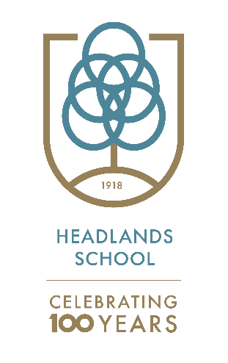
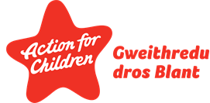

Key stage 3/Middle School
Teaching and Learning Policy 2021/22

This policy describes the approach to teaching and learning within the key stage 3/Middle School department at Headlands School. It is essential reading for members of staff new to the school who should incorporate its principles into their practice. It should also be reviewed regularly by current members of staff. It should be fully understood in the context of the whole range of other Headlands Schools policy documents.

1 The Curriculum Aims

In key stage 3/Middle School we provide an engaging, differentiated approach to learning which develops skills, knowledge and understanding. An emphasis is placed on a thematic, topic-based approach through the International Middle Years Curriculum (IMYC) to encourage curiosity and creativity. We use the four main purposes set out in New Curriculum for Wales to ensure we are meeting the needs of the pupils. The four purposes include providing opportunities for all our pupils to become:

- ambitious, capable learners, ready to learn throughout their lives
- enterprising, creative contributors, ready to play a full part in life and work
- ethical, informed citizens of Wales and the world, ready to be citizens of Wales and the world
- healthy, confident individuals, ready to lead fulfilling lives as valued members of society

The four purposes are supported by the delivery of skills within the six areas of Learning and Experience. These are -

- Expressive Arts
- Health and Wellbeing
- Humanities, Languages
- Literacy and Communication
- Mathematics and Numeracy
- Science and Technology.

Each area of learning and experience contribute in different ways to the pupil’s development of skills. This is set out in the teaching model.

The curriculum is delivered in a safe, nurturing environment that aims to develop emotional wellbeing and encourages positive social interactions. Our behaviour management model Therapeutic Crisis Intervention (TCI) works at developing and improving pupils’ coping skills. All staff also use our DDP approaches to support pupils develop their relationships and positive sense of self. These approaches are underpinned in all our work with the pupils.

2 Literacy – Numeracy – Digital Competence

In key stage 3/ Middle School we have a focus on developing skills, especially with a focus on literacy, numeracy and digital competence. Literacy is developed through specific teaching and in all thematic learning sessions. The Nurture groups use a variety of literacy interventions including Rapid Reading, Rapid Writing, Wordsmith, Handwriting Motorway, Bug Club and Literacy Shed.

Developing numeracy skills is key throughout middle school. Pupils have opportunities in specific maths sessions alongside developing number skills in a variety of thematic, practical and off-site activities. This includes Mastery, Abacus and White Rose Maths.

ICT is used in a variety of innovative ways to extend and enrich the pupils’ learning experience, including the use of iPads, a large variety of apps, green screen and editing software.

3 Teaching Models

All staff are encouraged to use OTP (Outstanding Teaching Programme) strategies in their work with the pupils, giving more opportunities to work together and share ideas.

In key stage 3/ Middle School we develop pupils engagement and attainment by combining a variety of teaching models into our daily routine. Our understanding of the learners’ needs and the outcomes desired allows us to choose the most appropriate teaching and learning model for each particular session and learner. Pupils complete short tasks in order to maintain their engagement with the activity.

The curriculum for Wales highlights the 6 areas of learning. Below are a list of activities delivered in key stage 3/ Middle School that match to the 6 areas.

6 Areas of Learning Experience | HOW?
Humanities | IMYC topics, Offsite educational trips and activities, PSHE lessons,
Expressive Arts | Access to drama club, access to guitar lessons, radio station and music room.  Seasonal showcases
Languages, literacy and communication | Literacy in thematic learning and specific literacy. Rapid reading, rapid writing, wordsmith and Bug Club .Literacy Shed.
Mathematics and Numeracy | Abacus, LNF Mastery. White Rose Maths.
Science and Technology | IMYC topics, DCF
Health and well-being | IMYC, PSE,PE, Duke of Edinburgh and Cycle Studies  DDP, Nurture Principles, TCI, Growth Mindset

Staffing

Within the key stage 3/ Middle School department we have two full-time higher-level teaching assistants (HLTAs), eight full-time teaching assistants (TAs). When required certain pupils receive extra support throughout the day. The teaching assistants play an integral part in the pupils learning journey and deliver sessions and lead on activities within the classroom.

4 Assessment

Staff in key stage 3/Middle School use Connecting Steps and the Boxall Profile Online as the main tools for tracking academic and social and emotional progress. Teachers use assessments to help improve learning as well as to indicate the stage a pupil is with their learning. Pupils are encouraged to use self -assessment and peer assessment to focus areas for development and identify strengths.

Key stage 3/Middle School data is used to formulate our self-evaluation and school improvement areas. We evaluate key data on pupil progress on a termly basis to identify our strengths and areas for improvement.

In key stage 3/Middle School we carefully and thoughtfully prepare pupils transitioning into key stage 4/Upper School. Careers Wales meetings and reviews are completed to develop a clear pathway for pupils to work towards in year 9.

5 Learning Environment

The key stage 3 department is modelled on the practice of Nurture Groups and strictly follows the six Key Nurture Principles:
- Children’s learning is understood developmentally
- The classroom offers a safe base
- Nurture is important for the development of self-esteem
- Language is a vital mean of communication
- All behaviour is communication
- Transitions are significant in the lives of children

Classroom displays are used to enhance pupils learning. Displays are updated throughout the year.

6 Additional learning needs

Where pupils are identified to have specific additional learning needs, the staff team around them will modify their curriculum to allow them to feel safe and develop their social and emotional skills. These interventions aim to support pupils working in small groups and making good academic progress. Educational visits are an essential part of the curriculum in key stage three. All pupils have the opportunity to take part in school trips and activities. The aim of these trips and activities is to let pupils experience an understanding of the world around them, consolidate and enhance the learning that takes place in the classroom and to allow the pupils the opportunity to share experiences with their peers and adults.

This local policy conforms to the Independent School Standards Wales Regulations 2003:
Section 1(2)(a)(ii) - 1(2)(b) - 1(2)(c)

