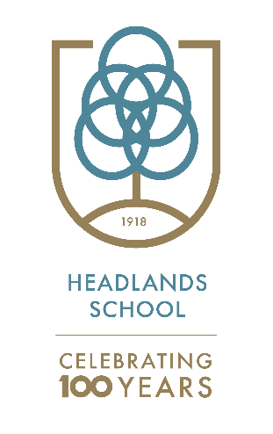
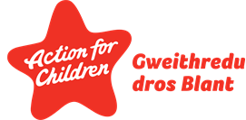

Headlands School
Curriculum Policy 2021/2022

Headlands School provides education for pupils aged 7 to 19. We offer education to young people who have difficulty learning as a result of emotional, behavioural and social difficulties and Autism Spectrum Conditions (ASC). Our approach is informed by attachment principles which are woven throughout the work all staff carry out within both our education and residential settings.

All pupils at Headlands School have experienced significant difficulties in both a home and school setting. Many pupils learning has been affected by early childhood experiences. We develop our behaviour management skills through regular training and evaluation. We use Therapeutic Crisis Intervention (TCI) as a model to support all pupils improve their coping skills.

Our curriculum uses the principles of DDP (Dyadic Developmental Practice), a relational approach, that is embedded by all staff at Headlands School. As a result, our model’s main principles are -

- Providing all pupils with a safe and consistent learning environment
- Ensuring all staff act as positive role models
- Allowing all pupils to have access to a range of learning experiences that meets their needs and builds their academic, social and emotional skills

If the pupils can experience these principles, they can achieve the following outcomes -

- Build a positive sense of self
- Develop positive and trusting relationships
- Develop more effective coping strategies
- Achieve relevant and worthwhile qualifications and engage in a variety of learning experiences

The school is organised in 4 key stages, that all develop the 4 purposes of the curriculum, where all our pupils will be -

- ambitious, capable learners | - healthy, confident individuals
- enterprising, creative contributors | - ethical, informed citizens

Through our broad and balanced curriculum all pupils will be able to build and develop their skills and engage in the 6 areas of learning identified in the ‘Successful Futures’ Curriculum for Wales document.

These include -

Expressive arts | Humanities | Mathematics and numeracy
Health and well-being | Languages, literacy and communication | Science and technology

At Headlands School we aim to build and develop the skills of all pupils as they move through the school. At the core of our philosophy is creating a safe learning base from which to develop and build trusting relationships. This underpins all our activities at Headlands School. We have developed many creative and radical learning experiences that are aimed at engaging all pupils and supporting them to improve a wide range of skills over time. We firmly believe in improving all pupil’s key literacy, numeracy and digital competency skills through both a wide range of classroom-based activities as well as many experiences outside the classroom. Our extensive range of vocational opportunities support the development of these key skills alongside the benefits these activities have on developing key relationships. Relationships are central to allowing pupils to feel safe, learn and consequently achieve successful outcomes.

Staff will support all pupils developing and improving their literacy, numeracy and ICT skills. Where appropriate these skills will be developed in all areas of the curriculum.

Relationships and sexuality education (RSE) plays a vital role in enhancing pupils’ well-being and safety. Our Personal Social Education (PSE) team ensure that all pupils receive the appropriate support and information throughout the whole school.

Human rights and the freedoms and protections to which all pupils are entitled play an imperative role in Headlands School. Through Human Rights Education and the United National Convention on the rights of the Child (UNCRC) we support pupils to now their rights and respect those of others.

All pupils who require additional support have access to various interventions to enable them to improve their specific social and emotional skills. Where required this is supported by psychological consultations.

Key stage overview

Key stage 2 (Lower School)
Our key stage 2 curriculum provide an exciting and differentiated approach to learning which develops a wide range of skills and knowledge. There is an emphasis on thematic learning that provides a broad and balanced range of learning experiences. The curriculum is delivered in a safe, nurturing environment with a key focus on developing key relationships, based on the nurture group principles. The teaching focuses on developing the key skills in the morning, particularly literacy and numeracy. All pupils have access to a wide range of ICT provision to develop their digital competency skills. We use the International Primary Curriculum (IPC) and the Cornerstones Programme to deliver a thematic approach covering the 6 areas of learning (see above). Pupils also have access to specific PSE, PE, DT, Art and Cycle Studies specialist teachers where they can consolidate these key areas of learning and develop new skills.

Key stage 3 (Middle School)
In key stage 3 we continue to use the nurture principles developed in key stage 2. Pupils improve their numeracy, literacy and ICT skills alongside using the International Middle Years Curriculum (IMYC) and a thematic based approach to learning to further develop the 6 areas of learning. Pupils are based in the same classroom (their safe base) with a key teacher and teaching assistants, as well as having access to various subject specialist areas including cycle studies, DT, music, D of E, Drama, PSE and PE. These wider opportunities develop wider interests and allow all pupils the opportunity to consolidate and improve their social and emotional skills.

Key stage 4 (Upper School)
Pupils in key stage 4 are provided with a broad and balanced range of academic and vocational experiences that promotes independent learning alongside gaining external qualifications. Pupils are given the opportunity to complete a range of work-related learning as well as meeting with Careers Wales to discuss future pathways relevant to the individual. The teaching model continues to follow the nurture principles and all pupils have a safe base from which the majority of lessons are delivered. There are a wide range of qualifications that pupils can access and achieve. These include, Entry Levels, Essential Skills Wales, GCSEs, D of E, BTEC, ASDAN and Agored Cymru qualifications.

Post-16
The post-16 programme aims to offer continuity and progression allowing all young people to develop a wide range of skills through an individually tailored pathway. This programme enables all young people to develop key transferable skills in various contexts within a safe and nurturing environment. Through developing these skills and experiences the programme aims to ensure that all young people in post-16 are prepared for the next stage of their educational journey. Careers Wales support all pupils to do this, through regular meetings and information sharing. There is a continued effort to develop appropriate independence skills both in the classroom and during community-based learning. The young people have the opportunity to build upon their qualifications achieved as well as complete courses in a wider range of qualifications including GCSE Health and Social Care and Welsh Baccalaureate.

Written by Joe Osbaldeston - Vice Principal, Education
Date: September 2021
Review September 2022

