


Headlands School
Safeguarding Local Policy
Introduction

All staff have a responsibility to act upon concerns we have regarding a young person’s safety. The effective protection of young people cannot be achieved by single agency acting on its own. This policy clarifies how individuals and the school should communicate and work together effectively in partnership in order to identify vulnerable young people, keep them safe from abuse and neglect, and improve outcomes for them.

This policy will be reviewed on a termly basis by the Designated Senior Person (DSP) for child protection, Principal and Senior Leadership Team (SLT) at Headlands School. It will also be reviewed by Action for Children’s safeguarding unit on an annual basis. This policy and procedure applies to all young people regardless of their gender, ethnicity, disability, sexuality or religion. Our policy applies to all staff, volunteers and governors working in the school.

Access to this policy is made to parents and carers in our admission pack and on our website.

There are three main elements to our policy:-

- Prevention through the teaching and pastoral support offered to young people
- Procedures for identifying and reporting child protection concerns.
- Support to young people who may have been abused and staff working with them.

1. Prevention

We recognise that high self-esteem, confidence, supportive friends and good lines of communication with a trusted adult helps to safeguard young people.

The school will -
- Establish and maintain an ethos where young people feel secure and are encouraged to talk, and are listened to. We will do this by building positive relationships and establishing student council and peer mentoring programmes.
- Ensure young people know that there are staff in the school they can approach if they are worried or in difficulty. This will be achieved by training all staff in child protection and safeguarding.
- The school also has an independent advocacy service - Tros Gynnal (029 2039 6974), who meet with all new young people and regularly with existing ones.
- Include in the curriculum, activities and opportunities for teaching which support young people develop the skills they need to stay safe from abuse and how to receive help. Our curriculum provides young people with information on substance abuse, sex and relationships education, anti-radicalisation, making decisions, anti-bullying, self-esteem, self-motivation and being valued.

2. Procedures

All staff have the responsibility to raise any safeguarding / child protection concerns they have.

- All child protection concerns must be made to our DSP Maxine Cahill (internal extension 208 or 07534480188). Staff members will be asked to complete a safeguarding concerns form.
- If Maxine Cahill is not available Gwen Currell (internal extension 216) is the deputy DSP for child protection. Other senior leaders who can assist you with child protection concerns include Matthew Burns (internal extension 205), Joe Osbaldeston (internal extension 215).
- During evening and weekend working there will be a senior manager on call who will advise you with your concerns.
- In the unlikely event of none of school managers being available then please make first contact to Jane Weeks 029 2022 2127 (National Director Wales)
- As of April 2021 you will be able to access Remedy force to discuss your safeguarding concerns under the following categories Allegations and Concerns / Serious Incidents / Other (Only access Remedyforce following consultation with a manger)
- Headlands School has a policy regarding use of physical restraint. If during a physical restraint a pupil is injured, the Principal and DSP for child protection must be notified immediately by the leader of the physical restraint. The completed record of the physical restraint and accident form should then be provided to the Principal and DSP.
- If an allegation relates to the Principal or the Chair of Governors the matter should be raised directly with the Vale of Glamorgan Social Services Child Protection contact. (01446 704730 for child protection) or (01446 700111 for POVA), or the local police (101). You should also inform Action for Children, Brigitte Gater 02920 222127 / Remedyforce.
- Young people and parents and carers can make referrals directly to Social Services if an allegation is in regard to the school or the staff. Refer to the contact details above.
- If a child protection referral is made to Social Services a copy should be sent to the young person’s local authority in their home area. This will be made by the DSP.
- When a referral is made to Social Services regarding an allegation of abuse, we will notify CIW (if relevant) and Action for Children Wales director Brigitte Gater 029 20222127 within 24 hours. Notification will be made by the DSP.
- All new staff at Headlands School have enhanced DBS check prior to commencing work. Action for Children has an approach for safer recruitment. All records of concern are kept confidential at the school.
- If you are a staff member with a child protection concern please refer to the guidance for staff responding to child protection concerns set out in (APPENDIX 1).

Procedures specific to POVA

- For our young people over the age of 18 the recording and reporting process for a POVA referral follows the same steps as that of a CP referral. Referrals must be completed on a VA1 form (APPENDIX 3)
- If a disclosure involves young people who are both over and under 18 years of age, staff must follow the referral procedure for child protection for young people under 18.

3. Support

Staff training

Headlands will ensure that all staff have the skills and knowledge to identify and deal with child protection/POVA concerns.

- All staff must attend Safeguarding training during induction and refresher training is provided biannually. Our training will focus on prevention and recognition of abuse, how to deal and respond to disclosures or suspicions of abuse, and how to follow our child protection procedures effectively.

- Induction training will include recognition of the signs and symptoms of abuse and the need to report any concerns to a manager. Failure to report actual or reasonably suspected abuse may lead to disciplinary proceedings. The safeguarding local policy is provided to new staff for them to read and familiarise themselves with the procedure, before signing the document.

- Headlands also provides staff with regular specific safeguarding training and maintains a record of attendance. This includes for example:
- WRAP (Workshops to Raise Awareness of Prevent) training relating to radicalisation and extremism issues. This training aims to support staff’s understanding of extremist views and ways of managing this behaviour.
- Restrictive Physical Intervention training and the school’s recording procedures.
- Therapeutic Crisis Intervention training for planning young people’ programmes on an individual basis.
- Administration of medication, basic first aid and fire-safety training.

- General safety

- The environment. It is everyone’s responsibility to ensure that the buildings, classroom and general site is safe and fit for purpose. Our caretaking team will ensure that the perimeter fencing is secure and clearly signposted. If you come across safety concerns regarding our buildings and outside spaces please take action to avoid using the space and report it immediately to a manager or our caretaker Morgan Stephens 07525731268.
- Visitors. Visitors include anyone that is not a member of our school based staff team. This can include contractors, parents/carers, and visiting teachers/professionals. All visitors to our school should report to reception to sign in. Visitors that access the wider site will be issued a badge which should be visible during their visit with us. When leaving visitors should sign out. It is important that you can see a visitors badge when you come across unfamiliar adults in our school. If you meet an unfamiliar adult that does not have a badge with the correct day/date/time information on it, you should ask them to report to reception immediately and let a manager know.
- Maintenance and building contractors. Building contractors should always sign in and meet with a member of our caretaking team before accessing the site or carrying out work. They will ensure that all building contractors have read/signed the asbestos management plan before working on our site.
- Building security. To ensure greater safety either the outside doors to building or individual classroom doors are locked. Exceptions will be based on a risk assessment.
- Lone working. For wider advice and guidance staff should refer to the Action for Children policy on lone working. However, all pupils have an individual risk assessment. This should be reviewed ahead of any activities that involve a member of staff working alone with pupils.
- Staff/pupil ratios in class. Due to the nature of our work our pupils can pose a high risk of violence or challenging behaviour. Therefore, we provide high levels of support in the classroom. Staff/pupil ratios are usually, 1 teacher and 2 teaching assistants: 6 pupils. These ratios are subject to change, and based on the assessed needs of the class group or individuals in the class group they could be higher or lower.
- Staff/pupil ratios in house. High levels of support are provided. We always have a minimum of 3 residential care staff during working hour and 2 during sleeping hours for all our houses.

Other relevant policies/documents:
- Procedures for responding to allegations or suspicions of abuse.
- Guidance for staff responding to suspicions or allegations of abuse.
- Managers guide to making a child protection referral.
- Whistle blowing.
- Anti-bullying Policy

- Leaflet for staff subject to a child protection enquiry.
- Guidance for signs of abuse.
- Wales Safeguarding Procedures. https://www.safeguarding.wales/ All Wales Child Protection Procedure 2021
- Action for Children, lone working

This policy is in line with:
- Wales Safeguarding Procedures. https://www.safeguarding.wales/ All Wales Child Protection Procedure 2021.
- “The Safe Parenting Handbook”
- WAG Circular 272/2021 Keeping Learners Safe. (The role of local authorities, governing bodies and proprietors of independent schools under the Education Act 2002)
- Action for Children’s Safeguarding standards
- Action for Children POVA procedure
- Department of Health Policy on Adult Safeguarding
- Headlands School Procedure for physical intervention
- Headlands Wellbeing Curriculum

This should be read in conjunction with -
- Action for Children’s Safeguarding Framework
- Headlands School policy for Anti-Bullying
- Managing allegations of abuse against staff, volunteers and carers procedures
- Whistle Blowing Policy
- Complaints Policy
- Headlands Notification Procedure
- Wales Child Protection Procedures. (Copy is kept with the Principal and Vice Principal Care).
- Guidance for managing safeguarding concern.

This local policy conforms to the Independent School Standards Wales Regulations 2003: Section: 3(2)

Note: All of these policies can be found on N:drive / internal process / policies / Child Protection / Safeguarding Policy

Author: Matthew Burns Matthew Burns
Date: JANUARY 2022
Review: JANUARY 2023

APPENDIX 1
Guidance for staff responding to a Child Protection / Vulnerable Adult concern

- Staff have identified a child protection / vulnerable adult concern.
- Ensure the safety of young person, assessing if he or she requires immediate medical attention.
- Allow the young person to talk freely, do not ask leading questions and don’t make him or her repeat their account.
- Do not promise to keep what you have been told a secret or confidential, as you have a responsibility to disclose information to those who need to know ensuring safety of the person.
- Report verbally to the Designated Senior Person (DSP) for Child Protection Maxine Cahill, 02920 709771 (208) / 07534480188 or nearest available Line Manager. Failure to do so may result in disciplinary proceedings.
- If an allegation relates to the Principal or the Chair of Governors the matter should be raised directly with the Vale of Glamorgan Social Services Child Protection contact. (01446 704730 for child protection) or (01446 700111 for POVA), or the local police (101). You should also inform Action for Children, Brigitte Gater 02920 222127 or Remedyforce.
- Record accurately, legibly and completely, including times, dates, other people involved and signatures. This information is to be recorded on Headlands School Child / Adult Protection Safeguarding Concern Form and make reference to this on DCF. Any additional information should be recorded on Headlands School Incident Report Form. This report should be completed prior to the staff member going off shift.
- Provide the completed Safeguarding Concern form to the DSP or nearest Manager who will advise you on any further action required. The DSP Maxine Cahill or Manager will determine if a referral needs to be made.
- Report your concern immediately DO NOT WAIT FOR THE YOUNG PERSON TO LEAVE SCHOOL FOR THE DAY OR WHEN YOU ARE NEXT IN THE HOUSE / SCHOOL OFFICE
- Do not confront the alleged abuser or contact parent of carer unless this has been agreed with DSP.
- All of the above MUST be completed prior to the staff member leaving work for the day.

If the behaviour of any adult or colleague towards young people causes you concern.

- Do not dismiss your concerns
- Do not confront the person about whom you have concerns
- Report your concerns to the DSP or line manager or follow the organisations “Allegations Against Staff, Volunteers, carers, procedure or “Whistle Blowing Procedures”.
- It is very important that you do not ignore or dismiss suspicions about another professional or colleague.
APPENDIX 2
Safeguarding Concern Form

Internal Headlands School Record

Name of young person:
DOB:

Date of Concern | Nature of Safeguarding Concern | Staff Member(s) Involved | Action Taken | Discussed with Senior Manager (date and whom)

APPENDIX 3
Protection of vulnerable adults form – VA 1

VA1 - Adult Protection Referral Form – Confidential (April 2011)
Please complete as fully as possible, especially ensuring that risks are identified.
For office use only
Date received by DLM -

Date of Stage 3 review -

1 About the Vulnerable Adult (Subject of referral)

Date alert/ concern raised | Date(s) of Incident(s) if known:
Name:
Client/Patient ID Number:
Date of birth: | Gender: Male Female
Vulnerable Adult/Client’s Current Address: | Other Vulnerable Adults / Children living at the property:
Tel Number: | Main Client Group (tick ONE only):  Elderly Mentally Infirm  Older Person  Visual Impairment  Hearing impairment  Learning Disability  Mental Health  Physical Disability  Substance Misuse  Other
Marital Status:
Ethnicity:
First Language:
Need Interpreter: Yes No
GP’s Name:
Telephone Number:

Surgery Address:

GP’s Name:  Telephone Number:  Surgery Address: | Case Status (Social Services use only :  Open/active  Open, review only  Closed  Not previously known  Other County
Next of kin: |  | Relationship:
Address:
Telephone number:
Is the vulnerable adult aware of the referral? Yes No
Has the vulnerable adult consented to the referral? Yes No
Is there any evidence to suggest that the vulnerable adult lacks mental capacity to consent to this referral? Yes No

2 About the alleged abuse

Type of alleged abuse (tick all relevant boxes)
Physical Sexual Emotional/Psychological Financial/Material
Neglect
Personal circumstances – Is the alleged victim subject to any legislative powers, e.g. Mental Health Act, Power of Attorney, DoLS?

Where did the alleged abuse occur?
Own Home  Perpetrator’s home  Relative’s Home Supported Tenancy  Sheltered  Accommodation. | Care Home – Residential  Care Home – Nursing  Care Home – Respite  Hospital – NHS  Hospital – Independent  NHS Group Home Hospice |  | Day care  Educational est.  Public place  Other - Please State:
Specific location of abuse (e.g. Ward/ Dept, Hospital, Care Home)
Is the abuse: Historical Current

Description of alleged abuse/injuries:

(continue on separate sheet of paper if necessary)
2a. Please use the section below to identify the position of any marks, bruising, wounds etc described above
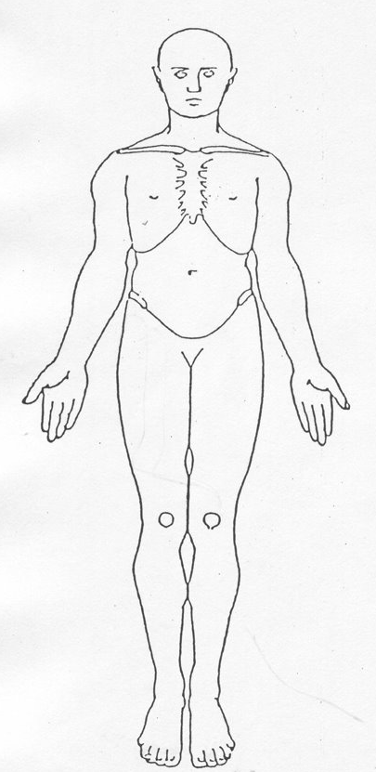 |  | 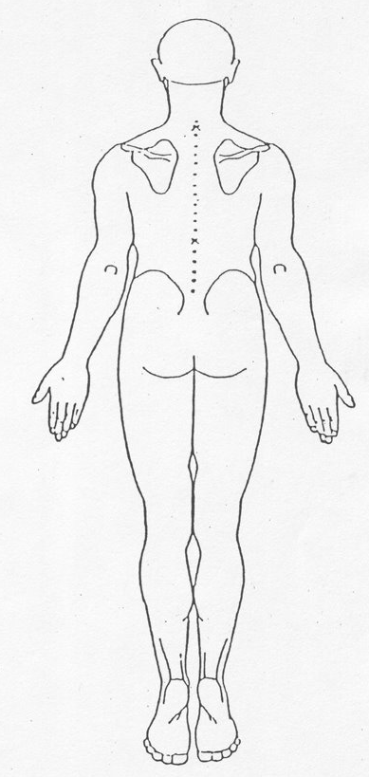
What steps have been taken to safeguard the vulnerable adult and by whom:

3 About the person(s) allegedly responsible for the abuse

Person 1:
Unknown at present:
Name: | Address:
Tel No: | Date of Birth:
Age: | Relationship to Alleged Victim:
Employing Agencies. List all known:
Is alleged perpetrator a vulnerable adult? Yes No Don’t know
Is alleged perpetrator a child? Yes No Don’t know
Is alleged perpetrator aware of the referral? Yes No Don’t know
Is the Alleged perpetrator known to social services? Yes No Don’t know
If yes, Client/Patient Database Number: |  | Team responsible:
Person 2:
Unknown at present:
Name: | Address:
Tel No: | Date of Birth:
Age: | Relationship to Alleged Victim:
Employing Agencies. List all known:
Is Alleged perpetrator a vulnerable adult? Yes No Don’t know
Is Alleged perpetrator a Child? Yes No Don’t know
Is Alleged perpetrator aware of the referral? Yes No Don’t know
Is the Alleged perpetrator known to social services? Yes No Don’t know
If yes, Client/Patient Database Number: |  | Team responsible:

If more than two alleged perpetrators have been identified please photocopy this page or add details in Section 8 – Additional information.

4 About the people who witnessed the incident(s)

Witness 1:
Name: | Address:
Tel No: | Relationship to victim (if any):
Is witness a child? Yes No Don’t know
Is witness a vulnerable adult? Yes No Don’t know
Is witness aware of referral? Yes No Don’t know

Witness 2:
Name: | Address:
Tel No: | Relationship to victim (if any):
Is witness a child? Yes No Don’t know
Is witness a vulnerable adult? Yes No Don’t know
Is witness aware of referral? Yes No Don’t know

5 About the person who first reported the concern (This is the first person to raise the alert – it may be the Vulnerable Adult, a witness or someone with concerns)

Is the person reporting the incident the vulnerable adult? Yes No
Is the person reporting the incident a witness to the incident? Yes No
Name: | Address:
Tel No: | Occupation/Relationship:
Date/Time report:
Does the reporter wish to remain anonymous? Yes No
If yes, please state why:

6 About the person who is referring the incident(s) to Social Services or Health Board

Is the person referring the incident a witness to the incident? Yes No
Name: | Address:
Tel No: | Occupation/Relationship:
Date/Time reported:
Does the referrer wish to remain anonymous? Yes No
If yes, please state why:

7 Details of person completing this form

Name: | Designation:
Agency: | Time/Date completed:
Signature: | Telephone number:

8 Additional Information

Where applicable, details of countersigning line manager:
Name: | Designation:
Signature: | Time/Date countersigned:

APPENDIX 4

Child Protection Concerns 1 (CP1) form

Note - All Local Authorities may ask for their specific MARF (Multi Agency Referral Form) to be completed.

Below is a copy of Action for Children’s Child Protection Concerns form.

Recording Of Child Protection Concerns CP1

Project Name: | Headlands School
Child’s Identification no:

Details of child/young person:
Name: |  | Known as:
D.O.B: | Ethnicity:
Address:

Telephone:
First Language:
Other language(s)
Is an interpreter or signer required?
Is child/young person’s name on the Local Authority Child Protection Register/subject to a Child Protection Plan?
If yes – which category?
Has a CP1 been completed for this child previously?
If yes what was the outcome?

Carers details:
Carers Name:

Relationship to child

Parental Responsibility?

Family Details:
 | Name: | D.O.B. | Address:
Mother: |  | __/__/__
Father: |  | __/__/__
Siblings: |  | __/__/__
Relevant others: |  | __/__/__

Details of Concern/Incident/Allegation/Observation:
Where incident occurred e.g. Group/Direct work/Home Visit/Other venue (please state)

Date of incident/allegation/observation

Facts/observations

What are the current risks for the child?

Have the child protection concerns been discussed with a parent or carer?
If not what is the reason for this?
GMSC to ensure that a copy is sent to the Directorate at divisional Office. Copy of the user’s file in the confidential section. Action to be followed by the P.M and discussed in supervision with GMSC.

Signed by member of staff reporting incident

Date and time

Date and time discussed with manager
Signed by manager ___________________________________

Name of person contacted in Children’s Services/Social Work Services/police etc:
Telephone no./e-mail
Date and time of contact :
Action agreed to be taken and by whom

Date confirmation letter sent to Children’s Services/Social Work Services:
CP1A Recording of Child Protection Concerns – Continuation Sheet
The continuation sheet is used in some countries/regions as a follow-up. Please refer to local procedures.

Name of child/young person:
Child’s Identification no:
Page number:

Please record further details of:

Concern/incident/allegation/observations/subsequent communications with police, Children’s Services/Social Work Services plus what action ensued.
Name of staff member reporting
Signature of member of staff reporting

Date and time:
Group Manager of Children’s Services/BMU Manager’s comments:

Name (please print):
Signature

Date copy sent to country/divisional office:

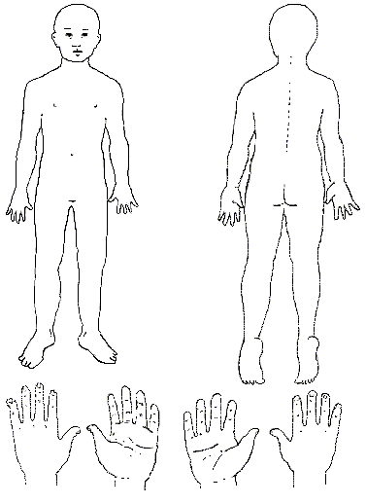

Body Map
NB ONLY to be used when there is no local ACPC/Safeguarding Board body map
Name of Child/Young Person………………………………………………………………………..

